TEAM ID: PNT2022TMID51052

PROJECT NAME: DemandEst - AI powered Food Demand Forecasting

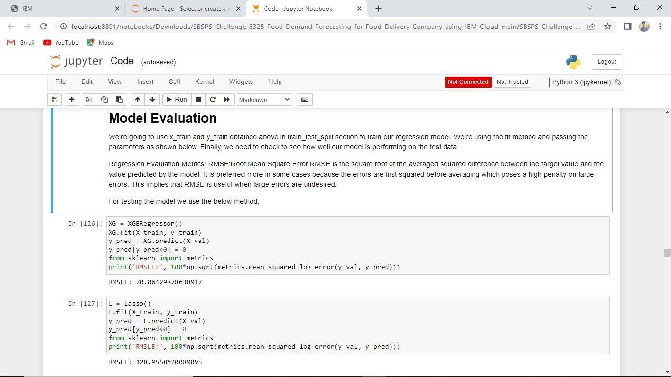Team Leader

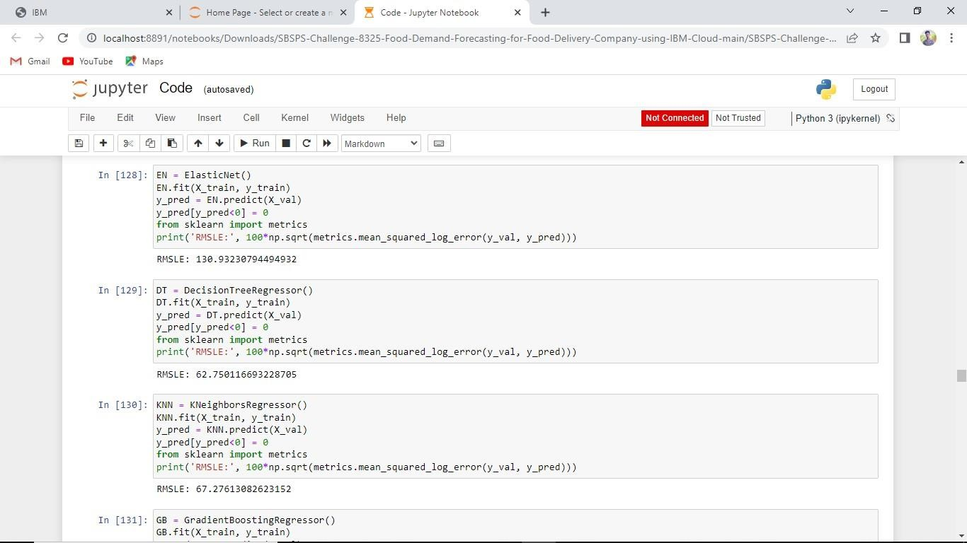

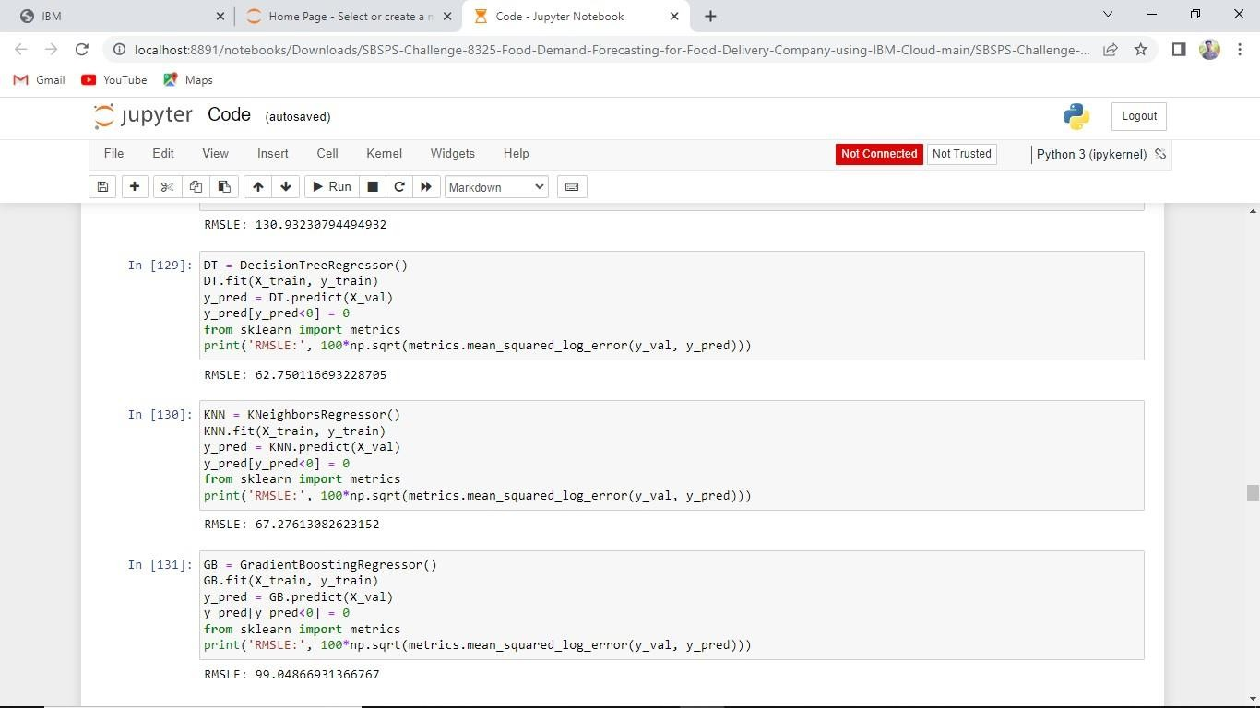

Team Member 1







Team Member 2





Team Member 3





